# ROI of a Social Media Campaign

# Tara Griffin

# Full Sail University

# Abstract

A campaign is a method used to advertise for a business to draw in new customers, visibility, awareness, or to attract sales. A campaign can be done through social media, or it can be done using flyers, TV ads, or other printed methods. When running a campaign, it is very important to know what your ROI, Return on Investment, is calculated up to because that will tell you how well the ads and the efforts worked.

# ROI of a Social Media Campaign

**Introduction**

A campaign is important for any business that wants to get noticed. I ran a campaign for my Candle Bar that I just recently opened in February this year. This campaign was done on social media, Facebook and Instagram. The campaign's goals were to bring awareness of the store location, bring awareness of the new business, and draw in new customers to the company.

**First Section**

**Campaign**

For my campaign, I decided to use Hootsuite, a PR app that helps coordinate social media posts and planning (Hootsuite, 2024). For this campaign, I used a picture of clients making candles that had recently come in, 5 hashtags, the call to action was for the customer to come into the store however, there was the option to comment, share, or like the post! At this time, there were no outside sources such as flyers, TV ads, or radio ads to help with this ad.

According to Hootsuite, the campaign reached 18,083 people, had 24, 585 impressions and 650 ad recallers. Upon looking at the ad itself, it was shared 4 times through the ad on Hootsuite. The Facebook followers on the main page did increase during this ad and more presence was brought to the website even though the goal was for people to come into the store. The CTR, also known as the Click Through Rate, was a little lower than I would have wanted for this ad at 0.05%. In the next ad, I will make sure to increase this by adding a video or something that will be more eye-catching.

Now that I have taken the course through Google Analytics, I know that this ad could use a lot of improvements (Google, 2022). Given that I am the one who created this ad, even though an app, I know it needs more work to obtain the right kind of ROI. For example, the audience could be adjusted, the media could be more enticing, and the hashtags could increase. Also, attaching Google Analytics to see activity on the page in general is more insightful.

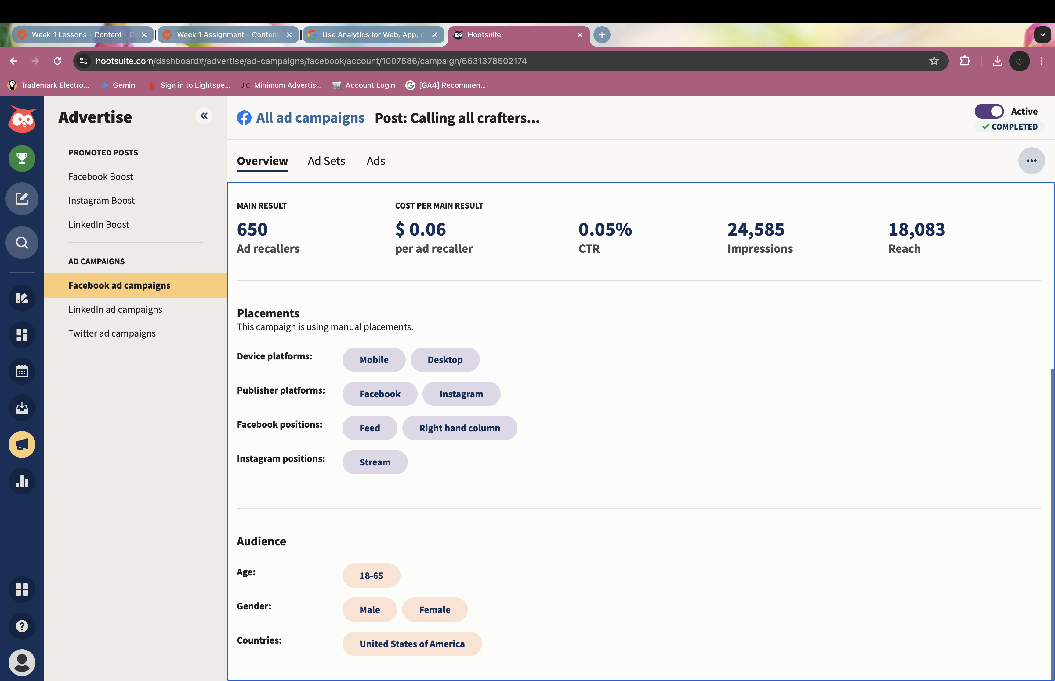

Screenshot of Hootsuite Campaign Results (Hootsuite,2024)

**Conclusion**

In conclusion, after looking at my campaign and taking the Google Analytics course, I have realized how important it is to use hashtags, add appealing eye-catching media, and have an inside look at what your ads are doing. It is important to have Google tags to know what your customers are doing on your web pages if you run a store, so you know where the focus is when you are running a campaign it is important to know what is grabbing attention and when and how. While this is a whole lot of information to cram in all at once, it is extremely useful when learning how to advertise. The best way for a business to succeed is for them to know they are profiting when spending money, that includes advertising!A screenshot of a computer

*\*Side Note: I am in the process of updating my PR website to a new web builder site, so here is a screenshot of my Candle Bar linked to Google Analytics.*

# References

Hootsuite; (2024); *Rise above the social media chaos;* <https://www.hootsuite.com/>

Google; Aug. 24, 2022; Discover the Next Generation of Google Analytics; <https://skillshop.exceedlms.com/student/path/66729-discover-the-next-generation-of-google-analytics?sid=491b14b2-9999-4caf-80c7-f1b2f53eced8&sid_i=0>

# Appendix

Each Appendix appears on its own page.